PF LAB 5 Tasks
Muhib Parvaiz
26K-3126

Task: 1
#include <stdio.h>

int main(){
float cel;

printf("Enter The Temp In Celciois: \n");
scanf("%f", &cel);

if (cel < 15){

printf("The Temp Is Cold!");
}
else if (cel >= 15 && cel < 30){
printf("The Temp Is Normal!");
}
else {
printf("The Temp Is Hot!");
}

return 0;
}
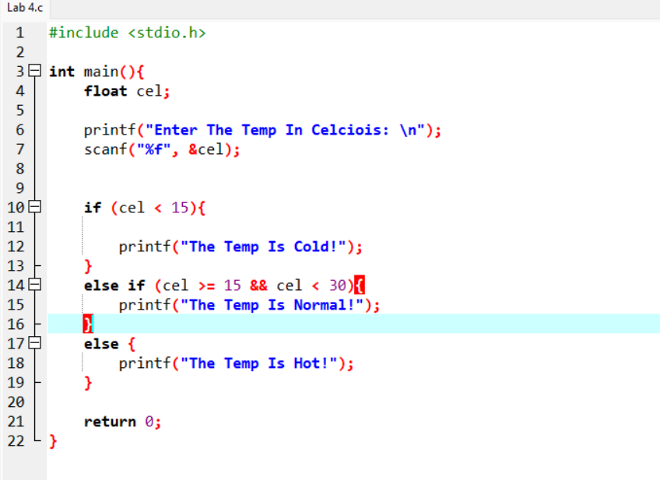
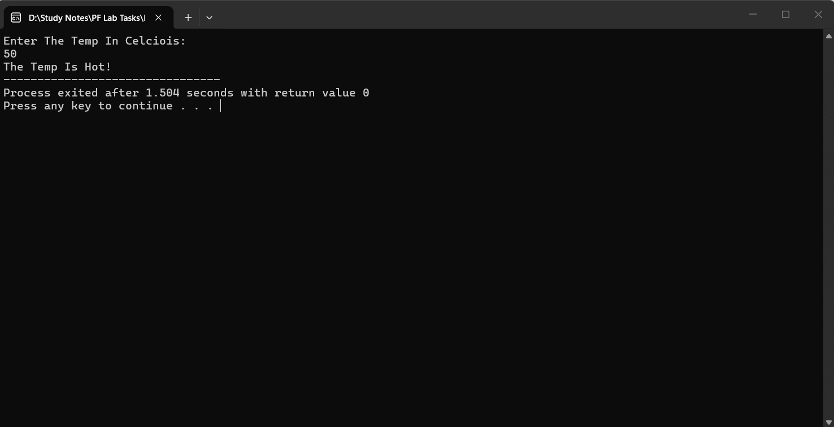

Task 02:
#include <stdio.h>

int main(){
int Balance;

printf("Enter The Balance: \n");
scanf("%d", &Balance);

if (Balance < 500){

printf("Low Balance");
}
else if (Balance >= 500 && Balance < 2000){
printf("Sufficent Balance");
}
else {
printf("Premium Balance");
}

return 0;
}
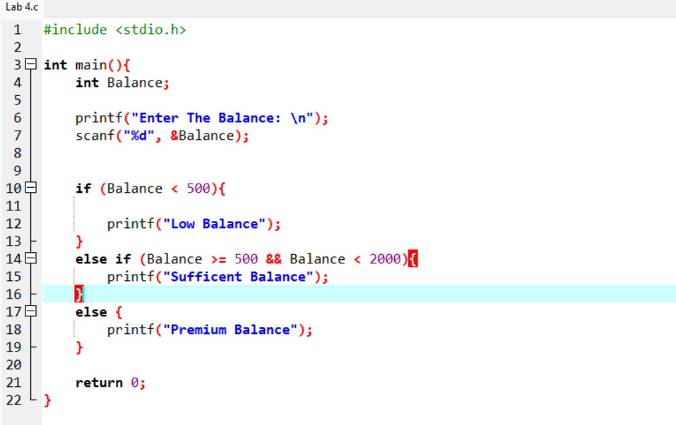
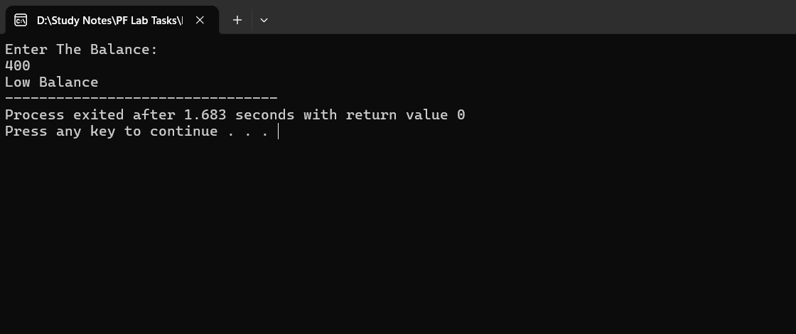
..

Task 3:
#include <stdio.h>

int main() {
int apt, doc, reg;

printf("Appointment? (1/0): ");
scanf("%d", &apt);

printf("Doctor available? (1/0): ");
scanf("%d", &doc);

printf("Registration done? (1/0): ");
scanf("%d", &reg);

if (apt == 1) {
if (doc == 1) {
if (reg == 1) {
printf("\nCan meet doctor.\n");
} else {
printf("\nUnavailable\n");
}
} else {
printf("\nUnavailable\n");
}
} else {
printf("\n Unavailable\n");
}

return 0;
}
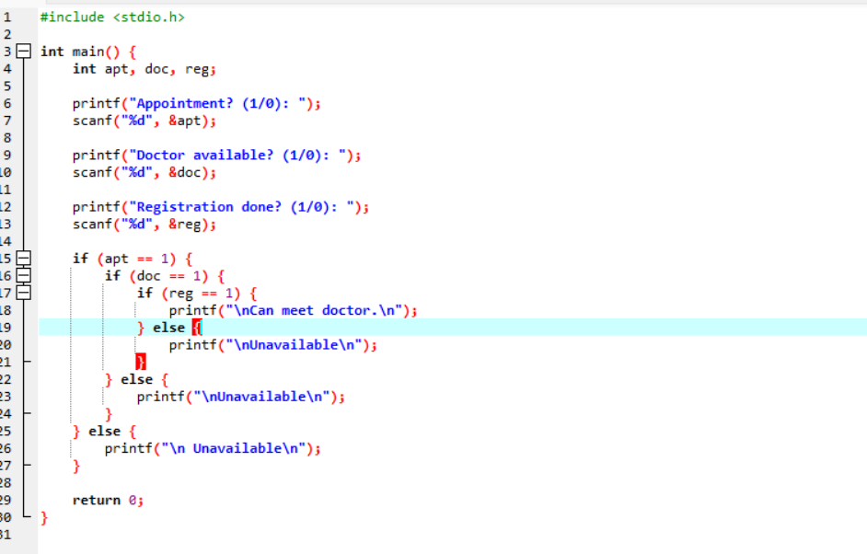

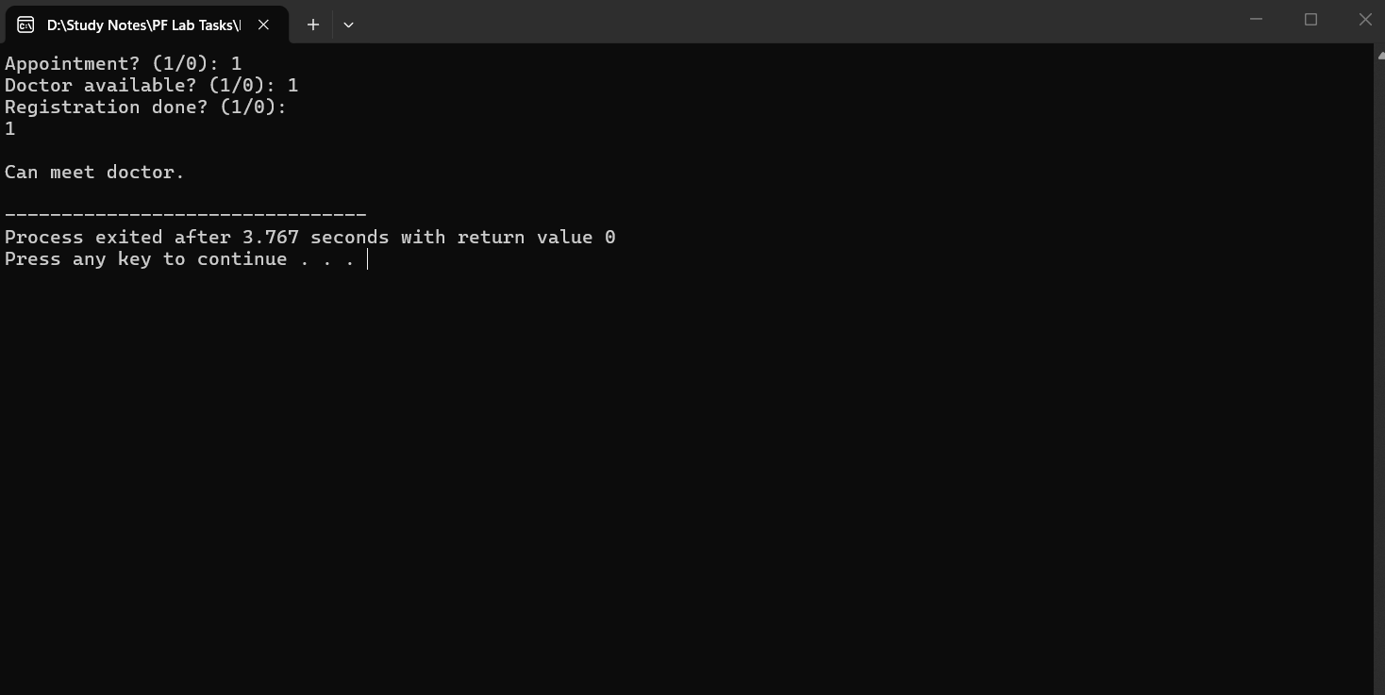

Task 04:
#include <stdio.h>

int main() {
int ro,ia,bs;

printf("Is The Restaurant Open? \n 1.Yes \n 2.No \n");
scanf("%d", &ro);
printf("Is The Item Available? \n 1.Yes \n 2.No \n");
scanf("%d", &ia);
printf("Is The Balance Sufficent? \n 1.Yes \n 2.No \n");
scanf("%d", &bs);

if (ro == 1){
if (ia == 1){

if (bs == 1){
printf("The Order Is Starting!");
}
else {
printf("Unable To Place Order");
}
}
else {
printf("Unable To Place Order");
}
}
else {
printf("Unable To Place Order");
}

return 0;
}
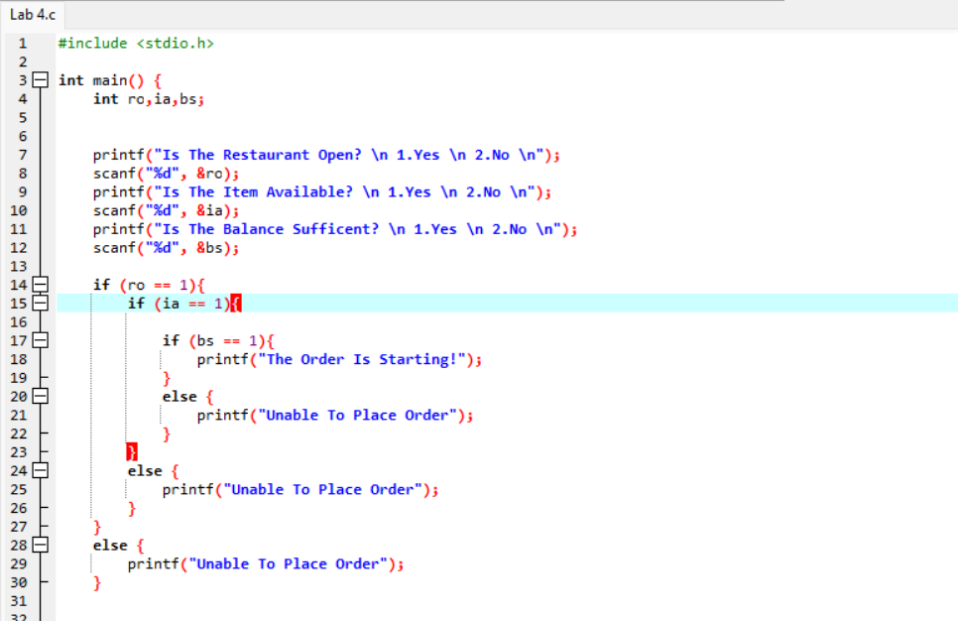
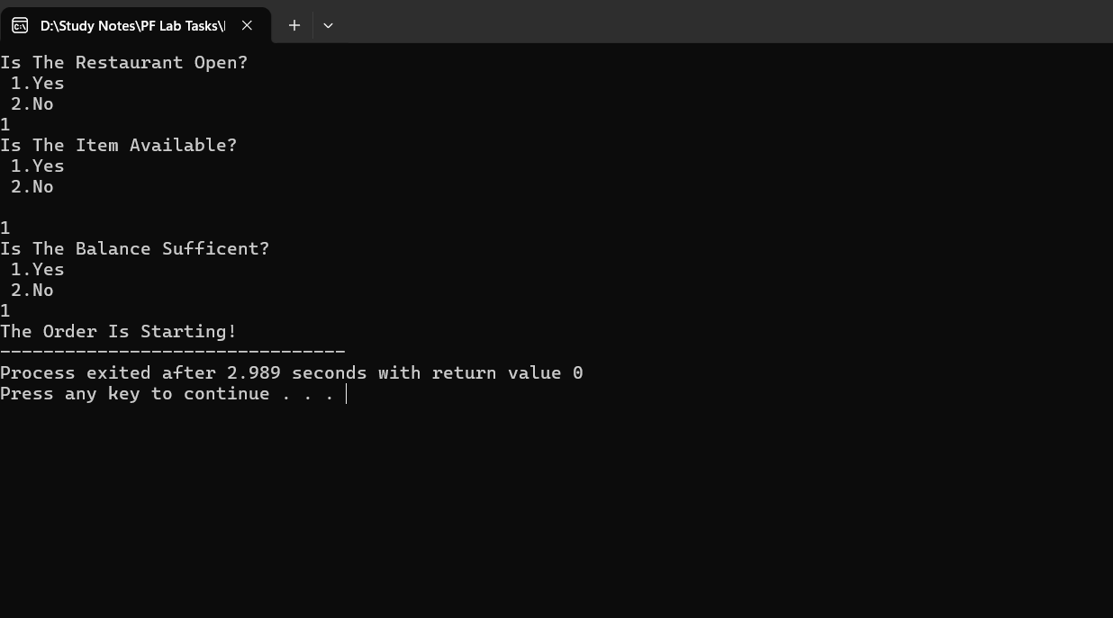

Task 05:.
#include <stdio.h>

int main () {

int opt,acc;

printf("Enter Your Desired Operation: \n 1.Balance Inquire \n 2.Cash Withdrawl \n 3.Cash Deposit \n 4.Pin Change \n Your Selected Choice: ");
scanf("%d",&opt);
switch (opt){

case 1:
case 2:
case 3:
case 4:
printf("Enter Your Account Tupe: \n 1.Savings Account \n 2. Current Account \n Your Choice:");
scanf("%d", &acc);
switch (acc){
case 1:
printf("Your Request For Savings Account Is Being Processed.");
break;

case 2:
printf("Your Request For Current Account Is Being Processed.");
break;
break;
default:
printf("Invalid Option Choses!");
break;

}
}
return 0;
}

